1. Implement the following design. Also demonstrate overriding

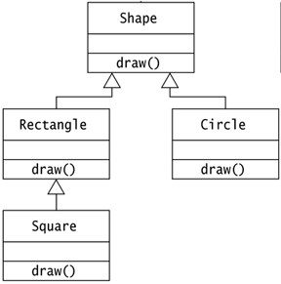

Demonstrate runtime polymorphism

1. Implement a BankAccount class with appropriate attributes and methods. Demonstrate method overloading to calculate the interest amount with default Rate of Interest or as per user specified Rate of Interest.

1. Create a Box class with attributes height, weight and depth. Initialise the Box objects in case all dimensions are specified, with no values specified and also in case when the Box is a cube where all its dimensions are equal. Also include method to calculate the volume of the Box object.
2. Create a Person class with attributes as name, age and password (private) and methods to read data. Also create a Student class inheriting Person class. Student class will have it's own attributes like name roll no, class, method to read and display. Also demonstrate the usage of super reference.
3. Write a java program to check palindrome number.
4. Java Program to count the total number of vowels and consonants in a string
5. Java Examples on Finding the Largest and Smallest Numbers in an Array. Let the number in the array be taken through command line.
6. Demonstrate runtime polymorphism
7. Implement the following design. Also demonstrate overriding
8. Create a InsufficientBalanceException class. This exception is generated when the withdrawl amount is greater than the existing balance.
9. Write java program to create a user defined Exception class known as NoVotingMinor. Accept the age of the voter, if the candidate is a minor, generate a exception NoVotingMinor.
10. Write java programs to demonstrate Exception handling using try, catch, throw, throws and finally statements.
11. Design a calculator using AWT
12. Write a program to create a form to accept user name. After submission display the a welcome message to the user.

1. Create two threads, one to display an even number and the other to print odd number. Synchronized the execution in a such a manner that numbers are displayed in sequence 1, 2, 3, 4,5,....
2. "Write a Java Program to calculate the Result. Result should consist of name, seatno, date, center number and marks of semester three exam. Create a User Defined Exception class MarksOutOfBoundsException, If Entered marks of any subject is greater than 100 or less than 0, and then program should create a user defined Exception of type MarksOutOfBoundsException and must have a provision to handle it."
3. Demonstrate 7-8 methods of Vector class.
4. Implement the following hierarchical inheritance

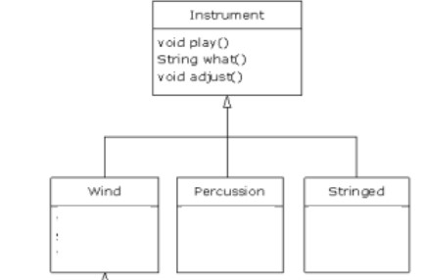

1. Create a user defined package called Figure having classes to implement Circle and Square. Write a program to import the package and find the area of Circle and Square.

1. Create a class Employee by extending Person class. Include appropriate attributes and methods.

1. Demonstrate order of call of constructorsn multi level hierarchy.

1. Print the sum, difference and product of two complex numbers by creating a class named 'Complex' with separate methods for each operation whose real and imaginary parts are entered by user.a

1. The Matrix class has methods for each of the following:
2. - get the number of rows
3. - get the number of columns
4. - set the elements of the matrix at given position (i,j)
5. - adding two matrices. If the matrices are not addable, ""Matrices cannot be added"" will be displayed.
6. Write a program to create a class Point with x and y as the attributes to represent a point is in 2D space. Implements methods to read, display and find the distance between two points.